The Ontologies You Shouldn’t Build Yourself: A Field Guide for Knowledge Graph Builders



Konrad Kaliciński
Follow
9 min read
·
Jul 2, 2026
77
3
SNOMED, FIBO, LKIF, Gene Ontology and the rest — what they are, who maintains them, and when to reuse instead of modeling from scratch

Why I’m walking this back a little
A while ago I argued that building an ontology for a knowledge graph is a process, not a diagram — you grow your classes as the data teaches you what it contains, you don’t freeze them upfront.
I stand by that. But it left out an obvious question: before you build anything, shouldn’t you check whether your domain already handed you an ontology? A lot of them come with decades of committee work, formal governance, and mappings to every other standard in the field. Rebuilding “Patient” and “Diagnosis” yourself isn’t craftsmanship; it’s rework.
So this is the other half: not how to build an ontology, but the catalog of ones you probably shouldn’t — who owns them, which industries run on them, and when reuse beats rolling your own.

First, the words — so we don’t mix them up
Neo4j published a piece on this in June, and it’s worth thirty seconds because people use these three terms as if they mean the same thing.
A taxonomy is a hierarchy. Parent, child, is-a. A tree of categories.
An ontology adds relationships and rules on top of that hierarchy. Not just “a Femur is a Bone,” but “a Fracture affects a Bone” and “a Bone is part of a Skeleton,” with constraints on what can connect to what. It’s a formal model of a domain’s concepts and how they relate.
A knowledge graph is what you get when you populate an ontology with actual data. The ontology is the schema and the vocabulary; the graph is the millions of instances filling it in.
That’s the whole reason the ontology matters. A property graph will happily run with almost no schema, and for plenty of jobs that’s the right call. But the moment you’re doing knowledge, structure stops being optional. Without an agreed model the same entity shows up under two labels, the same fact gets three different relationship types, and nobody can say which one is the real one. The ontology is what keeps a knowledge graph from drifting into a big pile of duplicated noise with edges.
Press enter or click to view image in full size
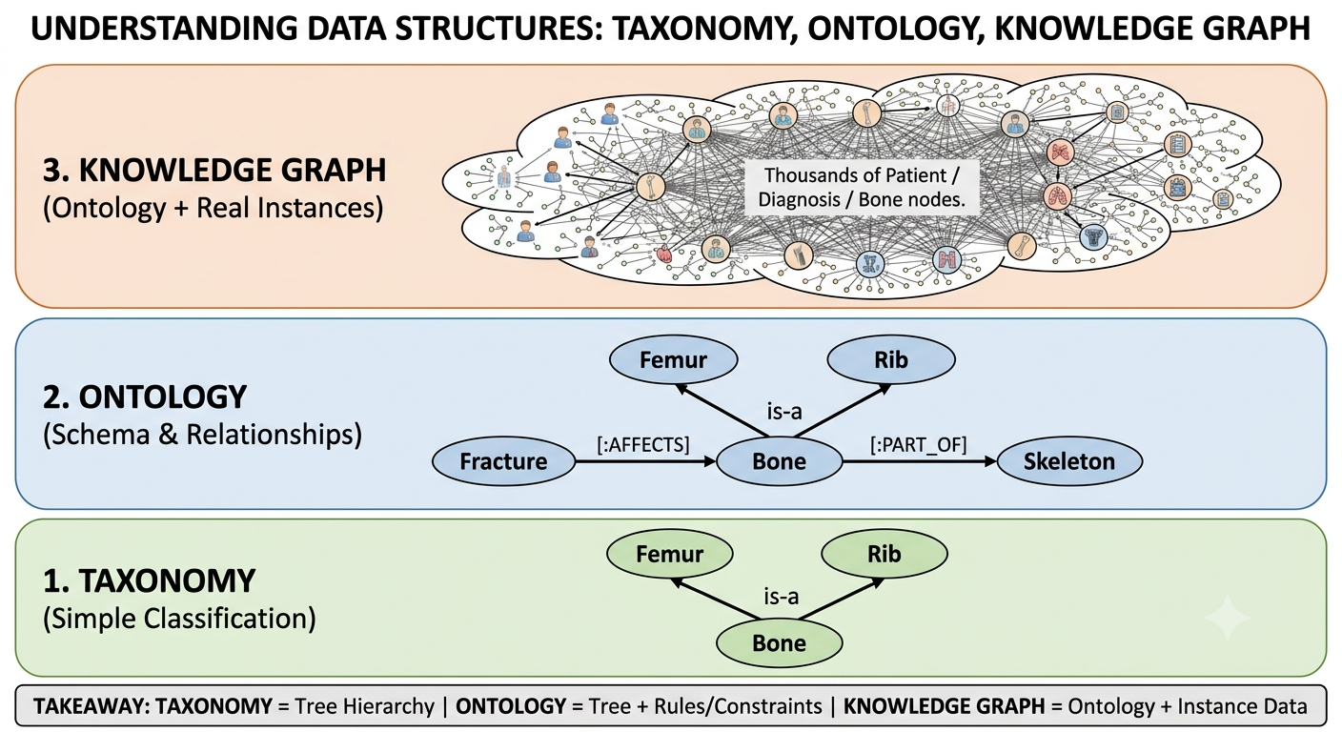
data structures — generated with gemini

Healthcare and pharma: the most crowded shelf
No domain has invested more in shared ontologies than medicine, mostly because getting a diagnosis wrong does real harm, and mislabeling a product photo does not.
SNOMED CT is the big one for clinical terminology — diseases, findings, procedures, body structures, organisms, hundreds of thousands of concepts, coordinated by SNOMED International and used in over 50 countries. If you’re modeling anything a clinician records in an EHR, this is the reference vocabulary. It also publishes maps to other standards, which matters more than it sounds.
ICD-11 is disease and cause-of-death classification, maintained by the World Health Organization and used for billing, epidemiology, and public health reporting across 150-plus countries. Where SNOMED CT is fine-grained clinical detail, ICD is the classification layer sitting above it. The two are related by explicit mappings, not merged.
MedDRA is the one people outside pharma rarely hear about. Owned by the ICH — the regulators themselves — it’s the terminology for adverse events and drug safety monitoring (pharmacovigilance). When a drug safety report moves between a company and a regulator, it speaks MedDRA, and official SNOMED-to-MedDRA maps let clinical and regulatory data talk.
RxNorm, from the US National Library of Medicine, normalizes drug names — the same medication sold under a dozen brand names collapses to one concept. The NLM also runs UMLS, the Metathesaurus that cross-maps SNOMED, ICD, RxNorm, and MedDRA — the nearest thing medicine has to a Rosetta Stone for its own vocabularies.
Gene Ontology is what a healthy, long-lived ontology looks like: gene function described through three linked pieces — the ontology, evidence-backed annotations, and causal models chaining them into pathways. As of mid-2025, it held over 1.1 million experimentally supported annotations from 185,000+ papers, maintained for two decades. Around it sits an ecosystem — the Human Phenotype Ontology, Mondo, the Monarch Initiative linking them across species.
That’s a whole stack of interlocking standards in one domain, mapped to each other on purpose. Ignore them and your medical KG becomes an island nobody else can query.

Finance: FIBO and the semantic operating system
Finance has largely standardized on one thing: FIBO, the Financial Industry Business Ontology. It’s a joint effort between the EDM Council, which drives the design with major financial institutions, and the OMG, which handles governance and publishes it as a formal standard.
The current production release carries roughly 2,446 classes spanning foundations, business entities, financial instruments, securities, and derivatives. Nobody reproduces 2,446 carefully-governed classes on a project deadline, and that’s the point: risk reporting, regulatory submissions, and increasingly agentic banking systems can all lean on the same vocabulary.
One writer called ontologies like FIBO the “semantic operating system” of modern banking. A bit much, maybe, but as banks wire up autonomous agents, a shared, machine-readable definition of a “counterparty” or a “collateral position” stops being nice-to-have.

Supply chain: less one big ontology, more a stack of standards
Supply chain is a good counterexample to “every domain has one ontology.” Here you assemble a few.
GS1 is the backbone — the organization behind the barcode. Its EPCIS standard plus the companion CBV (Core Business Vocabulary) is how companies share the what, when, where, why, and how of a product moving through a chain. Every scan event — shipped, received, inspected — lands in a common format another company reads the same way. For a traceability graph, EPCIS is the event vocabulary you want, and it maps cleanly onto a property graph because it’s already event-shaped.
SCOR (Supply Chain Operations Reference), now run by ASCM, is the model everyone uses in practice for the processes themselves — plan, source, make, deliver, return. Its 2025 Digital Standard built its information model on top of the W3C PROV ontology, the general-purpose vocabulary for provenance: who did what, to which thing, when. Provenance is exactly the question a knowledge graph answers well and a relational schema dreads.
Supply chain hasn’t settled on one big FIBO-style standard (there’s reference work like the IOF Supply Chain Ontology, but nothing dominant). You compose GS1 for identity and events, SCOR for process, PROV for provenance, and stitch them together — more assembly, but every piece is a standard someone else maintains.

Law, and the general-purpose shelf
Legal is less settled. LKIF, the Legal Knowledge Interchange Format, models the legal domain explicitly — obligations, permissions, prohibitions, rules, the structures you need to reason about regulation rather than just store it. It’s more academic in origin than SNOMED or FIBO and adoption is patchier, which tells you something about how much harder “encode the law” is than “encode a drug list.”
When nothing domain-specific fits, there’s the general-purpose layer — schema.org for generic People/Organizations/Places/Products, Wikidata for linking entities against a commonsense graph. Shallow, but useful glue.

One pattern across all of them
Notice who maintains these: the WHO, a consortium of regulators, the NLM, nonprofit standards bodies, academic consortia on public grants. Almost none are vendor products. That’s why they’re safe to build on — not a feature that gets deprecated when a company pivots, but infrastructure: slow, governed, boring in the best way, outliving any single product roadmap.
Press enter or click to view image in full size
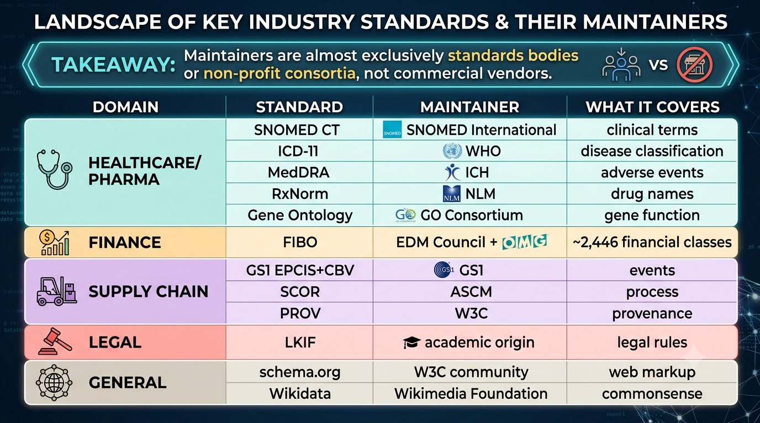
industry standards — generated with gemini

So when do you reuse, and when do you build?
This is the actual decision, and “always reuse” is wrong as often as “always build.” Drop the idea that reuse means importing everything — most of the time it means taking the slice that fits and leaving the rest on the shelf.
Reuse a standard when:
- You’re in a regulated or interoperable domain. If your data will ever be exchanged, audited, or mapped to another system, the standard vocabulary isn’t optional — a medical KG with its own invented diagnosis codes is one nobody can integrate.
- The concepts are stable. “Drug,” “diagnosis,” “security” have been argued to death already; you won’t out-model the ICH on adverse events.
- You want governance for free — someone else maintains versions, handles deprecations, publishes mappings. That’s real labor you’re offloading.
Build (or extend) when:
- Your domain is genuinely novel or narrow. Sports play-by-play events, a proprietary manufacturing process, an internal product taxonomy. No committee has standardized these, and forcing them into schema.org loses everything interesting.
- The concepts you need genuinely don’t exist in any standard — not just that the standard is big. Bigness alone isn’t a build trigger. Pulling 2,446 FIBO classes into a graph that needs forty is a maintenance tax, but the fix is a curated slice of those forty, not a schema of your own.
- You need to move fast on a closed system. If the KG never leaves your walls and never integrates outward, the interoperability argument evaporates, and a lean custom model wins.
The move that usually works is a hybrid, and you rarely take all of it. You take the slice that covers your concepts, curate it, extend it where your domain is special, and keep the standard’s identifiers so you can map outward later. For a narrow problem, that slice can be tiny. A KG that only answers drug-interaction questions doesn’t need all of SNOMED CT — a few hundred well-curated concepts, aligned to its codes, beat the whole thing dumped in and never looked at. The value was never the size. It’s that the piece you borrowed already agrees with everyone else’s.
The temptation on a live knowledge graph project is always to model from scratch because it feels cleaner. It rarely is. Clean custom schemas are how you end up privately reinventing SNOMED, one node label at a time.

The part that’s harder than it looks
Reuse is the right default, but it isn’t free. A few things bite.
Curation is the real work. Even after you’ve picked your slice, someone has to keep it current. Standards deprecate concepts, split them, remerge them. A curated subset only beats the full import if you actually maintain it — refresh it on a schedule, re-check the concepts you depend on, prune what you dropped. Skip that and your “curated” slice is just a stale one.
Mapping is where the work hides. SNOMED-to-MedDRA, ICD-to-SNOMED, your extensions to the standard — these exist because concepts almost never line up one-to-one. Maintaining them is ongoing, and a subtly wrong mapping is worse than none: now you trust a link that’s lying to you.
Fit is never perfect. A standard encodes someone else’s view of the domain — granularity you don’t want, gaps where your use case lives. Extending it without breaking what makes it a standard takes more understanding than building fresh, not less. Reuse trades modeling work for understanding work. Usually worth it. Not free.
And loading an ontology is not the same as reasoning with it. RDFS and OWL come with formal semantics and inference; property graphs often flatten that into labels and relationships and drop the logic. If you needed the reasoning, check you didn’t leave it at the door.

My thoughts
The domains furthest along with knowledge graphs, medicine and finance, are exactly the ones with mature shared ontologies. And that’s not a coincidence. The ontology is the on-ramp, and it’s why a healthcare KG built by one team can talk to a healthcare KG built by another that never met them.
I’d still be careful not to turn “reuse standards” into dogma. Half of what makes a knowledge graph valuable could be the part nobody has standardized — that’s the part your competitors haven’t modeled either. The standard gets you interoperable. Your extensions get you interesting. Knowing which half you’re on at any moment is most of the skill.
The one I’d actually bet on is agents. As more teams wire them onto their graphs, the value of a shared, machine-readable vocabulary goes up, not down. An agent reasoning over FIBO-grounded data is standing on 2,446 classes of built-up agreement about what the words mean. An agent reasoning over a schema someone invented last sprint is standing on vibes.
So before your next KG project, spend an afternoon on one question: does my domain already have an ontology? If it does, adopting even part of it will probably teach you more about your own data than a month of modeling from scratch. If it doesn’t, now you know you’re breaking new ground — a much more fun problem to have.

Resources
- Taxonomy vs. ontology vs. knowledge graph, Neo4j blog (June 2026): https://neo4j.com/blog/
- SNOMED International and SNOMED CT maps: https://www.snomed.org/maps
- MedDRA and its mappings: https://www.meddra.org/mapping
- RxNorm, US National Library of Medicine: https://www.nlm.nih.gov/research/umls/rxnorm/
- ICD-11, World Health Organization: https://icd.who.int/
- The Gene Ontology knowledgebase in 2026 (PMC): https://pmc.ncbi.nlm.nih.gov/articles/PMC12807639/
- FIBO, EDM Council: https://edmcouncil.org/financial-industry-business-ontology/
- FIBO specification (OMG): https://spec.edmcouncil.org/fibo/
- GS1 EPCIS & CBV (supply chain visibility): https://www.gs1.org/standards/epcis
- SCOR Digital Standard, ASCM (2025): https://www.ascm.org/corporate-transformation/standards-tools/scor-ds/
- W3C PROV provenance ontology: https://www.w3.org/TR/prov-overview/
- IOF Supply Chain Reference Ontology: https://labs.engineering.asu.edu/semantics/ontology-download/iof-reference-ontologies/iof-supply-chain-structure/
- Financial Regulation Ontology and LKIF references: https://finregont.com/reference-ontologies/
- “The Semantic Operating System for Modern Banking” (Medium): https://medium.com/@balajibal/the-semantic-operating-system-for-modern-banking-off-the-shelf-ontologies-1fc5cc83eb18

